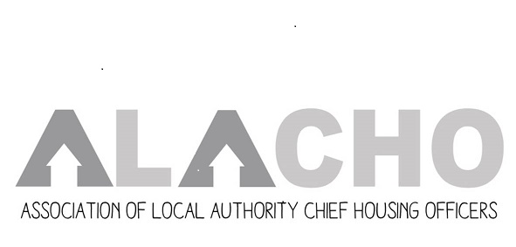
John Kerr
Co-Chair
Housing Development and Homelessness Manager
West Dunbartonshire Council
john.kerr@west-dunbarton.gov.uk

John Mills
Co-Chair
Head of Housing Services
Fife Council
John.mills@fife.gov.uk

Tony Cain
(ALACHO Policy Manager)
Tony.cain@alacho.org
Mobile: 07908 460989

ALACHO Deep Dive
Adaptations review
Legislation and guidance
Programme
Thursday 27 August 2026

Programme

- Welcome and purpose of the session
Tony Cain, ALACHO Policy manager

- Progress update
A quick update on the review to date

- Legislation Governance and Guidance
The next three parts of the discussion are intended to run in sequence, first exploring the core housing legislation relating to adaptations- we’re looking to explore how well it works, where the gaps are and what improvements may be needed. There after we will look at the arrangements for the delegation of these functions to Integrated Joint Boards, focusing on the effectiveness of these arrangements including service delivery and governance and finish with a look at the current statutory guidance on the provision of equipment and adaptations and how well that is supporting good outcomes.

  - The Housing acts
  - Housing Scotland act 2001 Section 92- generally seems to be little used
  - Housing Scotland act 2006 Section 71(1)(b)- the scheme of assistance

  - The Public Bodies (Joint Working) (Scotland) Act 2014
  - Adaptations, Aids and Equipment Advice Note
  - The Public Bodies (Joint Working) (Prescribed Local Authority Functions etc.) (Scotland) Regulations 2014

  - Guidance
  - Equipment and adaptations: guidance on provision - gov.scot

- Next steps

